# Having a Blood Test

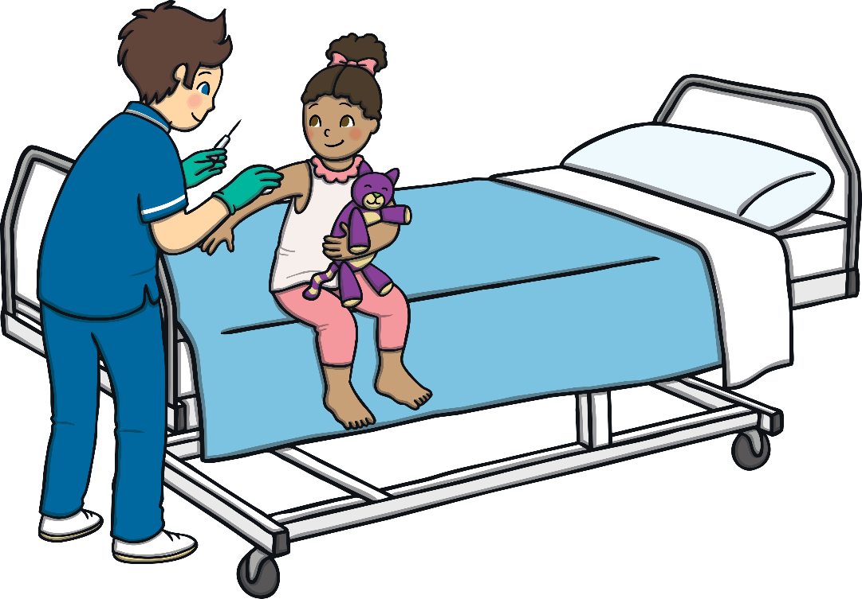

My name is ________________.

I am ____ years old.

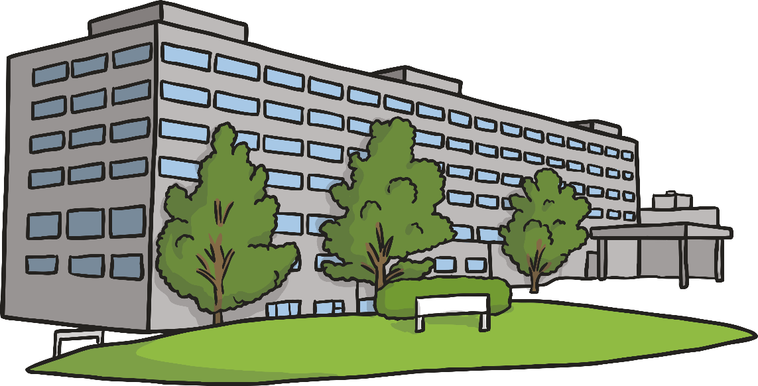

I am going to the hospital to have a blood test.

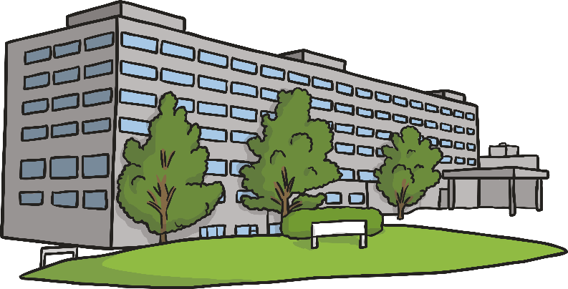_[adult’s name]___ will go to the hospital with me.

We will sit in the waiting room.

While we wait, I can _ [add in favoured activity] __



When my name is called out, it is my turn.

__ [adult’s name] ___ will come with me.

We will walk to see the nurse.

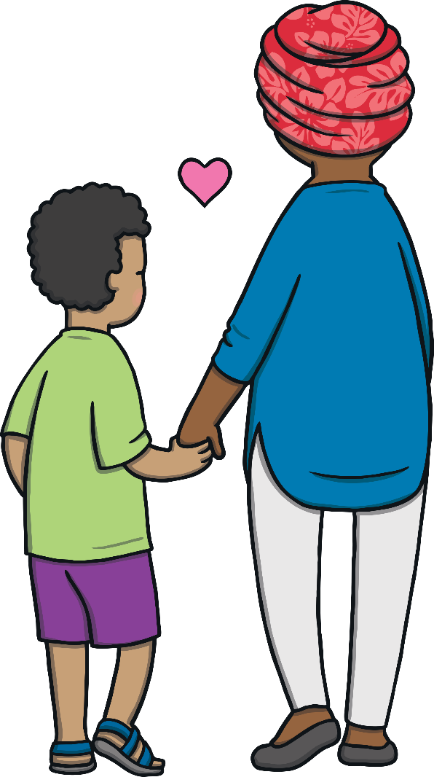

The nurse will tell me what will happen.

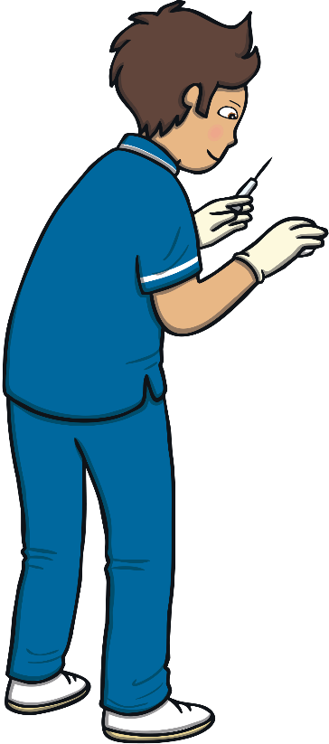I will have to sit very still.

_ [adult’s name] _ can sit with me and hold my hand.

This is OK.

I will show my arm to the nurse.

The nurse will put a band around my arm.

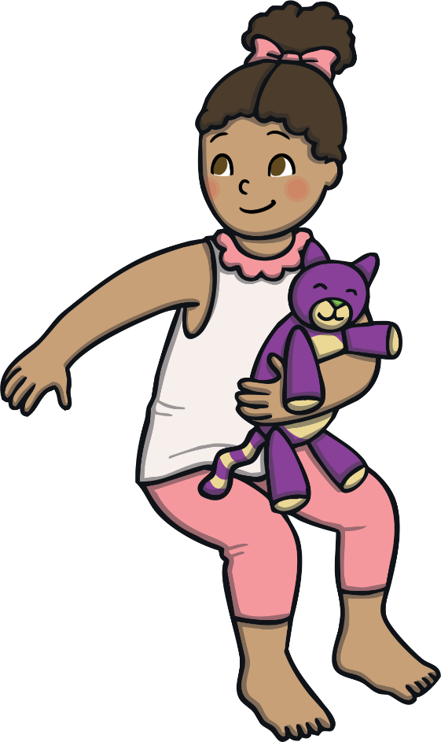

The nurse will clean my arm.

This is OK.

The nurse will use a needle to get the blood out.

The blood will flow from my arm into the tube.

The nurse will take out the needle and put some cotton wool on my arm.

The blood test is finished!



The nurse will be proud of me for having my blood test.

___ [adult’s name] ____ will be proud of me for having my blood test.