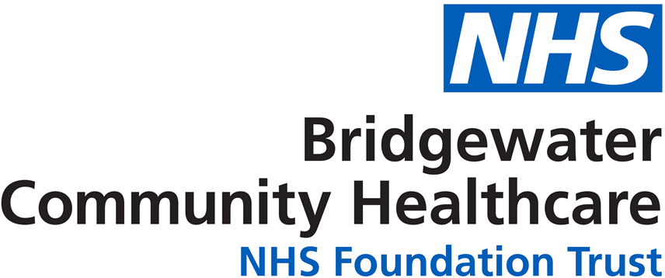

Information for staff and parents to contact the School Nurse during the Covid-19 Pandemic

 | Telephone the School Nurse teams on:  0151 495 5200 for Widnes Schools  01928 593056 for Runcorn Schools
 | Access to our Facebook page  www.facebook.com/halton019service/
 | Tweet us on  @halton019
 | Email us on  bchft.0-19widnes@nhs.net  bchft.0-19runcorn@nhs.net
